**IOP Sprint 7_Cycle 1 & 2**

**CHG00XXXX**

**Business Requirement Document**

|  |  |
| --- | --- |
| Document Name: | **BRD_IOP_Sprint 7_Cycle 1 & 2** |
| Document ID: | PROJ_CHG00XXXX_BRD_01 |
| Document Owner: | Kunal Agarwal |
| Document Version: | V1.2 |
| Document Date: | 09/22/2022 |
| Document Status: | Approved |

Table of Contents

2 Document Control 3

2.1 Document Location 3

2.2 Document Distribution 3

2.3 Document History 3

2.4 Requirements Reference 3

3 Overview and Scope 3

3.1 Scope Definitions 3

3.2 Assumptions & Dependencies 4

3.3 Transaction Volume 5

3.4 Frequency and Timing 5

3.5 Initiating Process / Transaction / Program 5

4 Detailed Functional Requirements 5

4.1 Cycle 1 5

4.2 Out of Scope: 8

5 Testing Requirements 8

5.1 Test Scenarios: 8

5.2 Testing Considerations/Dependencies 8

6 Parking Lot Items 8

7 Appendix 9

7.1 Open questions 9

7.2 Snippets from current app 9

7.3 Glossary of Terms: - Optional 9

# Document Control

## Document Location

## Document Distribution

|  |  |
| --- | --- |
| Deliverable Name | BRD_IOP_Sprint 7_Cycle 1 & 2 |
| Author | Kunal Agarwal |
| Reviewer | Rajesh Satewar |
| Approver | Luke Monceaux, Sergio Rivera & Rob Nelson |
| Status | Approved |

## Document History

|  |  |  |
| --- | --- | --- |
| Version | Details of Change | Release Date |
| 1.0 | Initial draft | 09/10/2022 |
| 1.1 | Review | 09/19/2022 |
| 1.2 | Final version | 09/20/2022 |

## Requirements Reference

|  |  |  |  |
| --- | --- | --- | --- |
| # | Requirement Details | Blueprint Reference | Release |
|  |  |  |  |
|  |  |  |  |

# Overview and Scope

## Scope Definitions

Below are the requirements for IOP Sprint 7:

* **Cycle 1**
  + Inquiry comments to be populated from Dispatch resolution details
  + ROC/POT/Engineer users should be able to create an Inquiry from scratch for facility, well pad and well level
  + Auto populate Issue classification & description as comments in dispatch task from Inquiry
  + Operators under SSE program should receive only certain dispatch tasks before their training is completed.
  + Foreman/ROC to have real time visibility, of the current “**IN-PROGRESS**” task of an operator
  + Record the exact Resolution time for a given task
  + Only one task can be in “**In-Progress**” status for an Operator.
  + Ability for an operator to see all the comments without making the task in-progress status
  + Field Operator should not be able to resolve tasks from the Task list screen.
  + Allow multiple route assignments in Shift Register
  + Replace daily Shift Register with **8 weeks** scheduling and ability to display Leaves from ADP.
  + Ability for Foreman to Cancel Pigging task (Assigned or Returned) which in turn cancel SAP work order also
  + Consolidation of two process i.e., **Pigging Launch** and **Pigging Retrieval** into one Pigging task.
  + Change in existing scheduled process for creating Pigging task from **daily** to **weekly** (Every Monday).
  + Field operator should be able to resolve future (same week) OBX tasks along with current task for the same well-pad.
  + Work Order module (PM App) to display “**Purchase Order”** (PO) number with associated Operations
  + User status & System status search options for Work Order module (PM App)
* **Cycle 2**
  + Add comments to “**Procount** “(EFS) and “**Prodview**” (Canada) from **Downtime Capture**, **Inquiry** & **Dispatch**.
  + Ability to edit “**Frac Pack**” for Engineers. Send “**Email”** notification for “**Tubing/Casing**” pressure post reaching the critical threshold values.
  + Provide “**Handover notes**” module access to POT users
  + Add “**Investigation**” details to Handover notes
  + Created and updated “**Dispatch** **task**, **Investigations** and **Inquiries**” to be displayed in Handover notes
  + Avoid duplicate activity of posting Handover notes to MS Teams by automating the process
  + New module (**PROVE**) on mobile, to display well performance data and trends
  + Add “**Location**, **Sub-classification** and **Tier**” details of a task on mobile push notification.
  + Ability to navigate to specific task on click of push notification
  + Extend active session on mobile to avoid session time-out
  + Delay in password authentication while switching the mobile app

## Assumptions & Dependencies

Following are the assumptions made at the requirement review sessions:

1. No task will be in “**IN-PROGRESS**” status when the changes are deployed.
2. Operator will not have a manual **pause** button in task management.
3. SuccessFactors to have correct data for operators' supervisor for Shift register
4. Field Operator should have SSE flag configured in SuccessFactors
5. Need to show the planned Leaves as maintained in ADP for Murphy Employees
6. On Shift/Off Shift pattern for operators to be shared for cutover
7. The working week for Pro Operator starts on WED & ends on TUE
8. Pigging operator works for 5 days(Mon-Fri) a week. They don’t have any Off Shift by default.
9. Pigging tasks will not be automatically canceled at the end of the week. If there is a task that is not cancelled by the end of the week, then next week there are going to be two tasks for the same pipeline.
10. Pigging Foreman will not be able to add comments while cancelling Pigging tasks.
11. Pigging Foreman cannot take any action on an “**In Progress**” task
12. If the operator accepts the OBX prompt, they must complete the task
13. No comments or Attachments to be shown in the Handover Notes
14. On click of Push Notification (Mobile), the task will be highlighted on the task list, it will not open the task detail page by default
15. Any task created at the field level can be assigned to any operator in that field irrespective of the routes
16. One well data to be shown displaying trends on mobile.
17. Pigging tasks can have multiple In Progress tasks
18. DL to be created for sending out Frac notification emails
19. MS team channels to be shared to post Handover details.
20. List of Sub classifications to be shared for dispatching tasks to SSE users
21. To be checked if CF walkthrough in Handover notes is to be removed

## Transaction Volume

TBD

## Frequency and Timing

TBD

## Initiating Process / Transaction / Program

# Detailed Functional Requirements

## Cycle 1

* **Inquiry**
* Inquiry comments to be populated from Dispatch resolution details
  + Capture all comments, attachments, and resolution notes from dispatch task.
  + Also, it should be visible in Location History, Inquiry, Investigation & Dispatch module
* ROC/POT/Engg users should be able to create an Inquiry from scratch for facility, well pad and well level
* Auto populate dispatch task from Inquiry
  + Location, description, issue classification, comments, attachments fields should be auto populated to dispatch task
* **Task Management**
* Operators under SSE program should receive dispatch tasks only for few sub classifications until their training is completed
  + Auto assignment or manual creation of the dispatch tasks according to specified task types until the SSE training is completed.
  + SSE status should be displayed in shift register
  + This process will help to mitigate the risk of an SSE field operator
* Operator should be able to capture the actual resolution time of dispatch task
  + Foreman/ROC to have real time visibility, of the current “**In-Progress**” task of an operator
  + Record the exact Resolution time for a given task
  + Operators should have clarity on which task to work on
  + Pro operator should have only one task as “**In-Progress**” status
* Ability for an operator to see all the comments without making the task as “**In-progress**” status
  + Field Operator should be able to see all the comments for a task in task list
* Field Operator should not be able to resolve tasks from the Task list screen.
  + Remove the resolve actions from task list screen such as “**Mark Resolved**”, “**Submit**” and “**Start Investigation**”
* **Shift Register**
* Allow multiple route assignments in Shift Register
  + Ability to assign multiple routes to an operator working on a field
  + There will be no changes to the current process of “**Base location”** (from assigned field).
  + If “**Base location”** is not assigned to an operator, then there will be no OBX task assigned to that user.
  + Different Operators can have common route assignment
  + Dispatch tasks for a well, well pad or facility can only be assigned to the operators who are assigned to that route.
* Replace daily Shift Register with **8 weeks** scheduling and ability to display vacation
  + Feature required to view and update an operator’s shift details for 8 weeks (including current week)
  + Need to show the Leaves of an operator updated by Foreman/ROC/Lead Operator in ADP for Murphy Employees
  + Existing Shift details captured for Field operator will be copied to display 8weeks view. Data to be copied are “**Shift type”** (Day, Night), “**Routes**”, “**Base location**” and “**On/ Off Shift**”
  + Export functionality to be provided to download(pdf) the shift details for all the operators and selected number of weeks.
  + Ability to see the unassigned routes
  + Providing the ability to update shift details with single action
* **Pigging**
* Introduction of two new personas “**Pigging Foreman**” (Maintenance Foreman) & “**Pigging Operator**” (Pipeline Maintenance Technician)
* Consolidation of two process i.e., **Pigging Launch** and **Pigging Retrieval** into one Pigging task.
* Change of existing schedule process from creating daily Pigging task to weekly (Every Monday).
* Pigging operator should record the quantity of debris (amount of return in gallons) in resolution details
* As soon as the operator resolve the Pigging task, then it should automatically “**TECO”** and “**CNF**” (Confirm) the work order in SAP
* “**Comments**”, “**Attachments**”, “**Resolutions description**”, “**Start Time**” (In-progress), “**Resolve Time**” and “**Debris**” data should also be updated in SAP workorder as part of the resolution process.
* Ability to Cancel Pigging task which in turn “**Cancel**” & “**TECO**” SAP work order
* Pigging Foreman can reassign the task to different operator or cancel the task
* Pigging Foreman is responsible to manage Shift register for Pigging Operators
* **OBX**
* When an operator is visiting a well or a well pad, then he/she should get an option to resolve open (same week) OBX task for all the wells within the same well pad
* **PM Work Order**
* Work Order module (PM App) to display “**Purchase Order**” (PO) number with associated Operations
* Search options for System status & user status
* User status to be shown in Work Order

**4.2. Cycle 2**

* **Downtime Capture**
* Comments need to be stored into Procount (EFS) from Downtime Capture for Wells and Flares.
* Comments need to be stored into Prodview (CA) from Downtime Capture for Wells.
* While closing Inquiry and Dispatch for a location, user should be able to add comments to Prodview (CA) system.
* While closing Inquiry and Dispatch for well, facility and flare location, user should be able to add comments to Procount (EFS) system
* **Offset Frac**
  + Ability to edit existing “**Frac Pack**”.
  + Feature to sort by Frac packs and Wells where 80% threshold for maximum Tubing/Casing pressure is reached.
  + Send “**Email”** notification for “**Tubing/Casing**” pressure post reaching the 80% of threshold values.
  + Provide Mark Complete feature to Engineer users.
* **Handover Notes:**
  + Provide “**Handover notes**” module access to POT users
  + Create a new “**Investigation**” section
  + Created and Updated “**Dispatch** **tasks**, **Investigations** and **Inquiries**” details to be displayed in Handover notes to track their daily activity
  + Avoid duplicate activity of posting Handover notes to MS Teams by automating the process
  + Combined Handover notes should be posted in MS Teams twice a Day for ROCs at 4 AM and 4 PM when shift ends
  + Handover notes for POTs to be posted once a day at 4 PM
  + Keep one Handover notes section instead of keeping 3 sections (Handover notes for ROC, Foreman and Leadership)
  + OBX tasks should not be included in tasks section as it can make clutter.
* **PROVE module on mobile**
  + New module (**PROVE**) on mobile, to display well performance data and trends
  + Data related to Prove to be shown on mobile as it is on web.
  + 3 days and 7 days average data to be displayed for trends.
  + EFS and Canada to show data in their local units
  + Operator should be able to open Prove module directly from dispatch task
  + Oil, water, gas and separator pressure, tubing and casing pressure to be displayed in trends
* **Push Notification/Mobile**
  + Add “**Location**, **Sub-classification** and **Tier**” details of a dispatch task to mobile push notification.
  + One task can be assigned to multiple operators. Once an operator picks that task then a notification is sent to remaining operators.
  + Ability to navigate to specific task on click of push notification
  + Extend active session on mobile to avoid session time-out
  + Delay (1 min) in password authentication while switching the mobile app

## Out of Scope:

* OBX tasks will be created based on the existing approach i.e., at well level only and not on well-pad level.
* Based on SSE identification, additional dispatch tasks for mentors will not get created.

# Testing Requirements

## Test Scenarios:

The testing is categorized into the following scenarios:

1. Foreman/ROC/Lead-Operator should be able to view and edit shift details for 8 weeks
2. Foreman/ROC/Lead-Operator should be able to assign/change base location and assign multiple routes
3. ROC should be able to see only operators on route in "Assign to Person" dropdown
4. ROC should be able to see dispatch resolution details as comments into Inquiry while creating an inquiry from dispatch
5. ROC should be able to see Inquiry classification & description in comments while creating a dispatch out of it
6. ROC/POT/Engineer should be able to create inquiry from any screen using the dedicated button for Facility, Well Pad and Wells
7. Foreman should be able to map task levels to SSE and ROC should be able to dispatch SSE for those specific sub-classification only
8. There should be only one task IN PROGRESS at any point of time for an operator
9. Operators should not be able to resolve tasks without opening them
10. Operator should be able to see comments without opening the task
11. Operator should see a prompt for any upcoming OBX task
12. Pigging Foreman should be able to re-assign/cancel a Workorder
13. ROC should be able to add comments while Downtime Capture
14. Engineer should be able to edit frac packs
15. POT should be able to create Handover Notes
16. Operator should be able to see trends & PROVE data on mobile App
17. Operators should be able to see detailed notification and should be able to navigate to specific tasks by clicking on the banner

## Testing Considerations/Dependencies

Test data is available in the required test environments.

# Parking Lot Items

| Issue No | Description | Assigned To | Status | Impact | Resolution |
| --- | --- | --- | --- | --- | --- |
| 1 | OBX task to be created on well pad level and not on well level. |  |  |  |  |
| 2 | Based on SSE identification, additional dispatch task for mentor to be created and dispatch tasks according to the training schedule |  |  |  |  |
| 3 | Shift Register mobile app for Foreman |  |  |  |  |
| 4 | Task scheduler to show tasks with different statuses in colors. |  |  |  |  |
| 5 | **Three tasks for breaks - 30/15/15 mins** |  |  |  |  |

# Appendix

## Open questions

1. Is Shift Register applicable to ALS & POTs? - No
2. Should POT see ALS operators on specified routes only while sending out an Investigation? - No

## Snippets from current app

Shift Register:

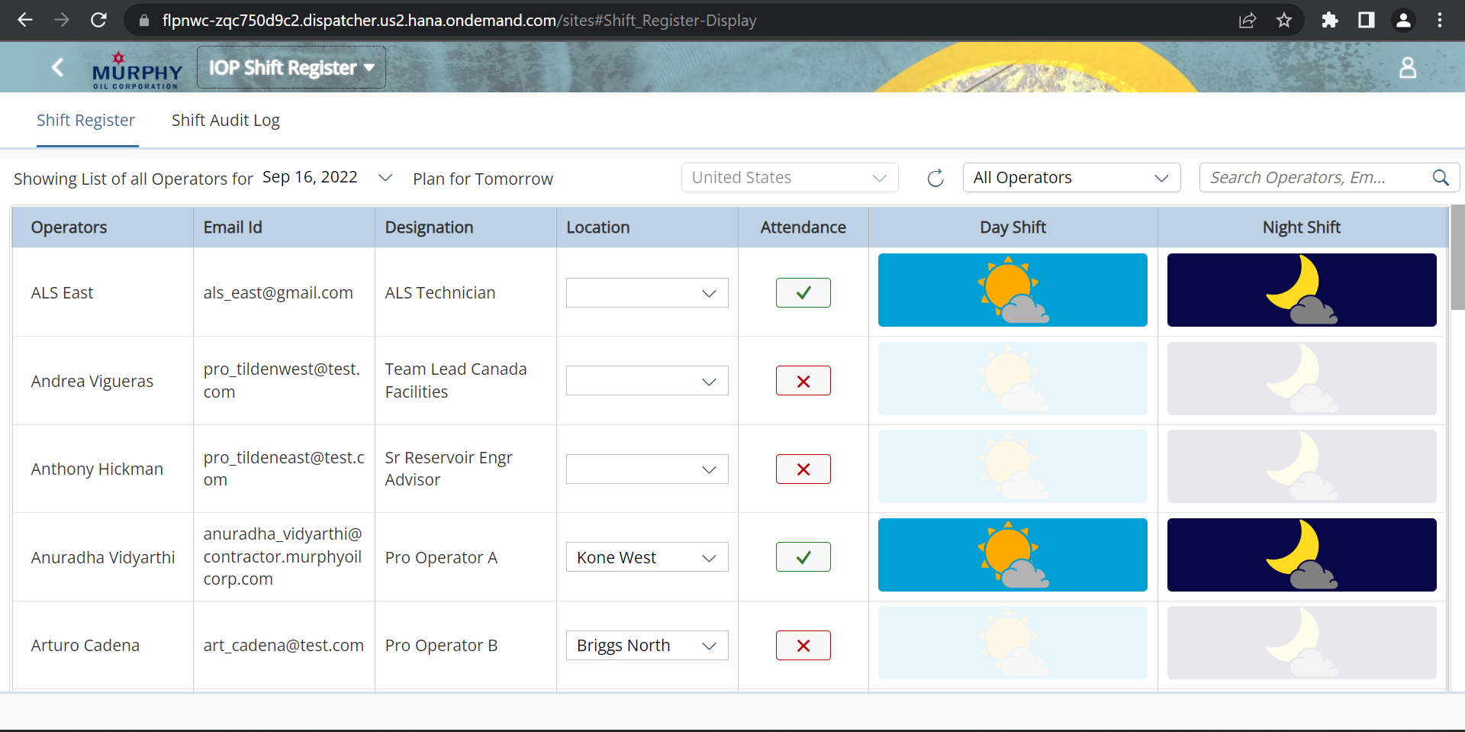

Mark Resolved/Start Inspection/Submit buttons on task list:

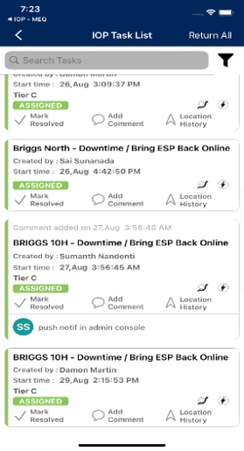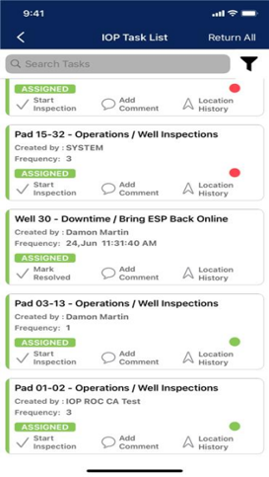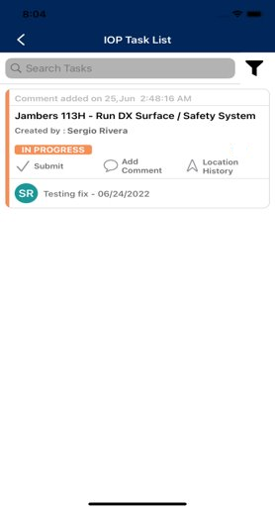

Pigging:

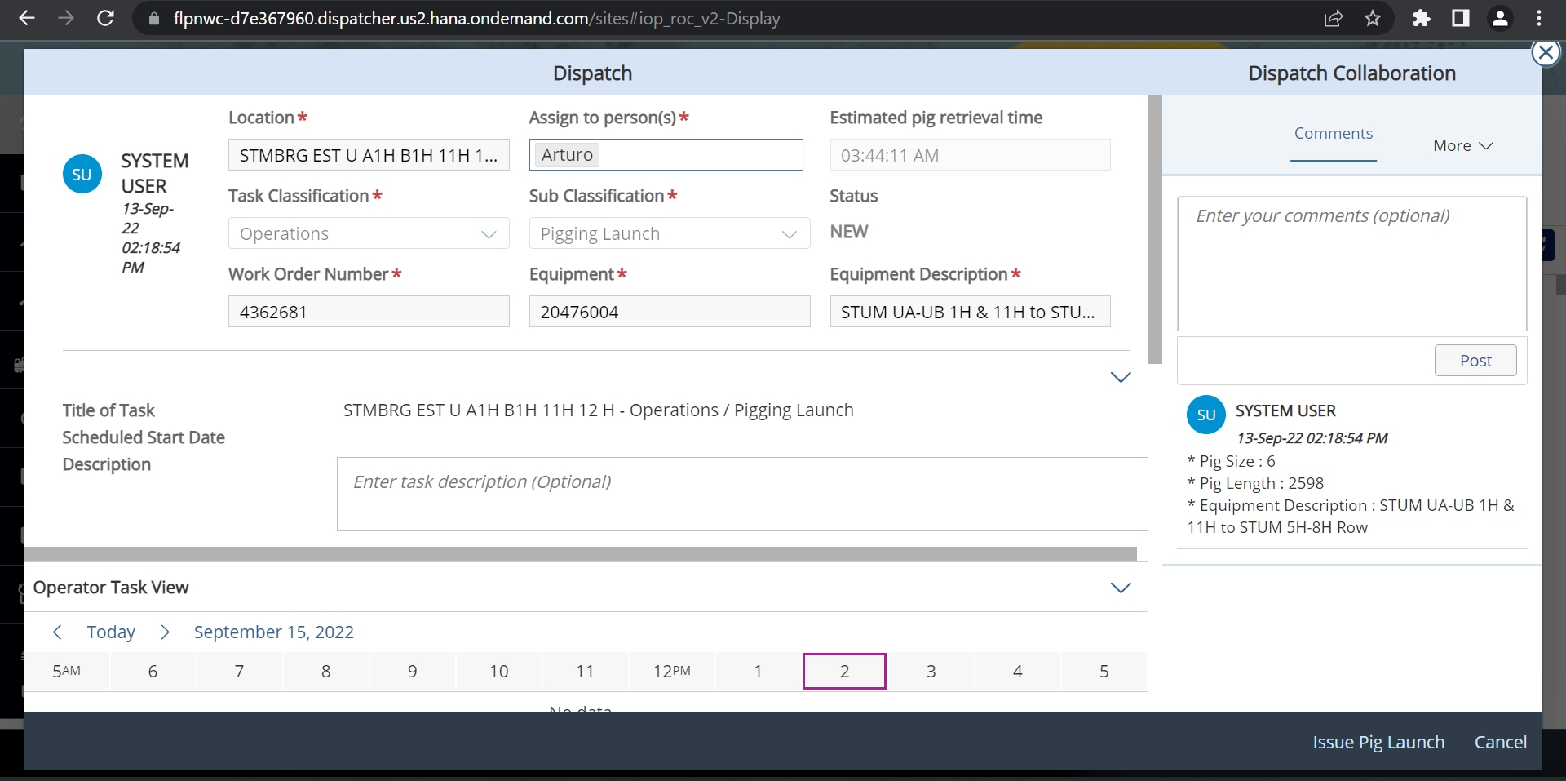

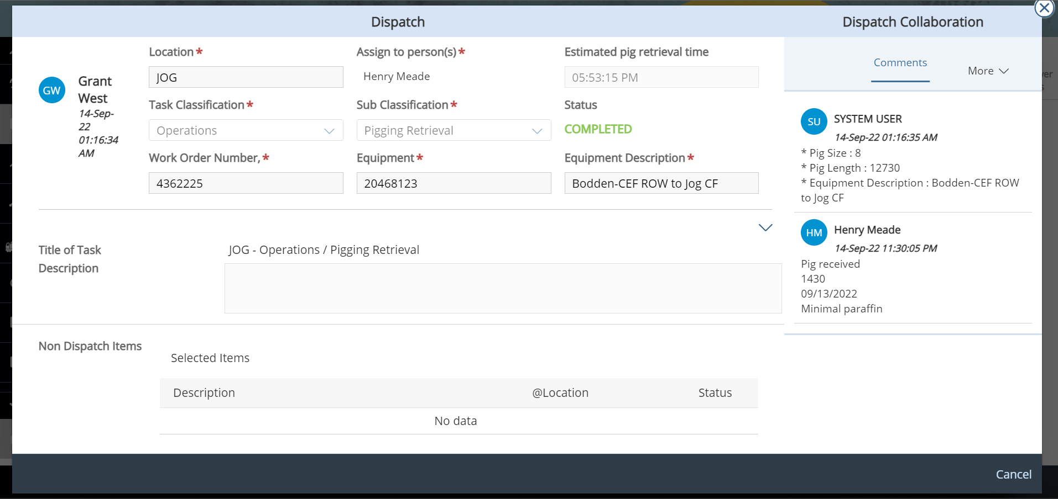

Task Scheduler:

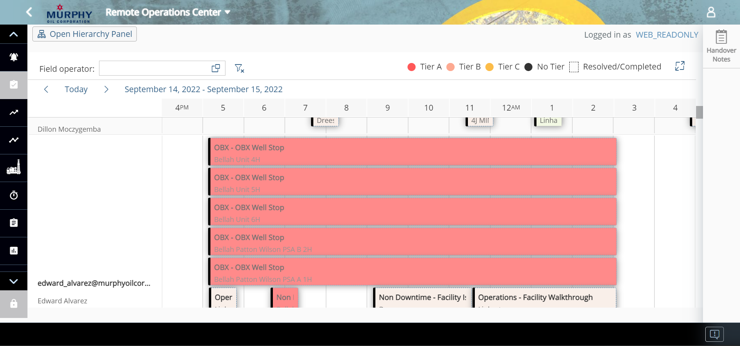

Downtime Capture:

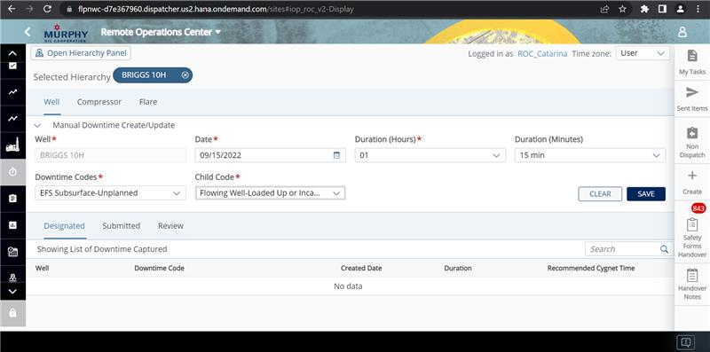

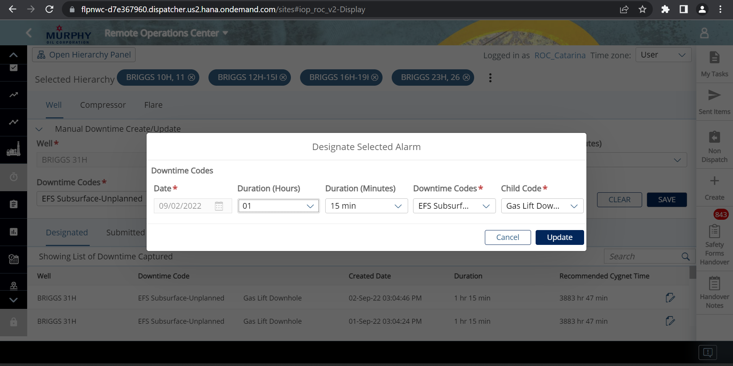

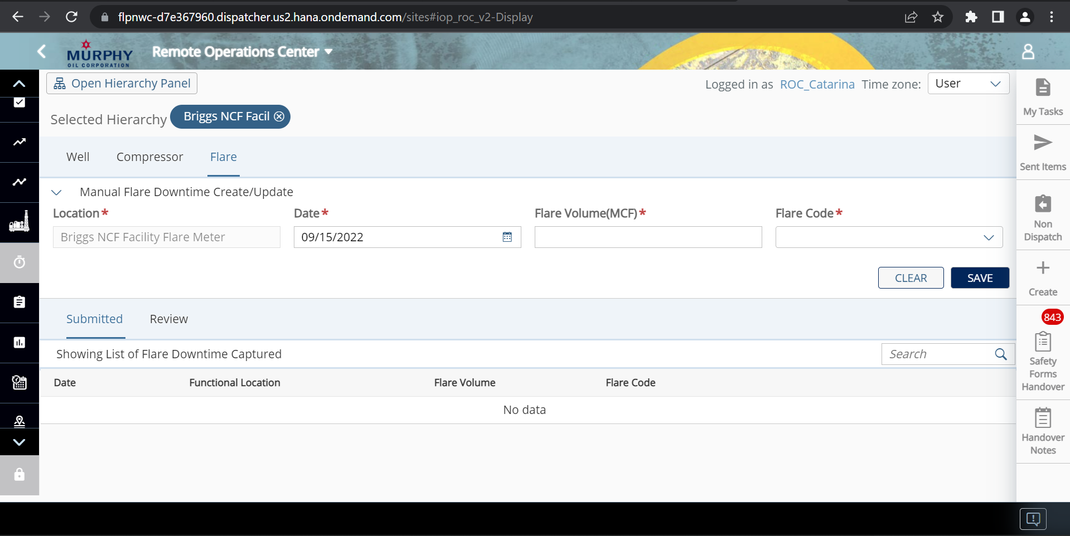

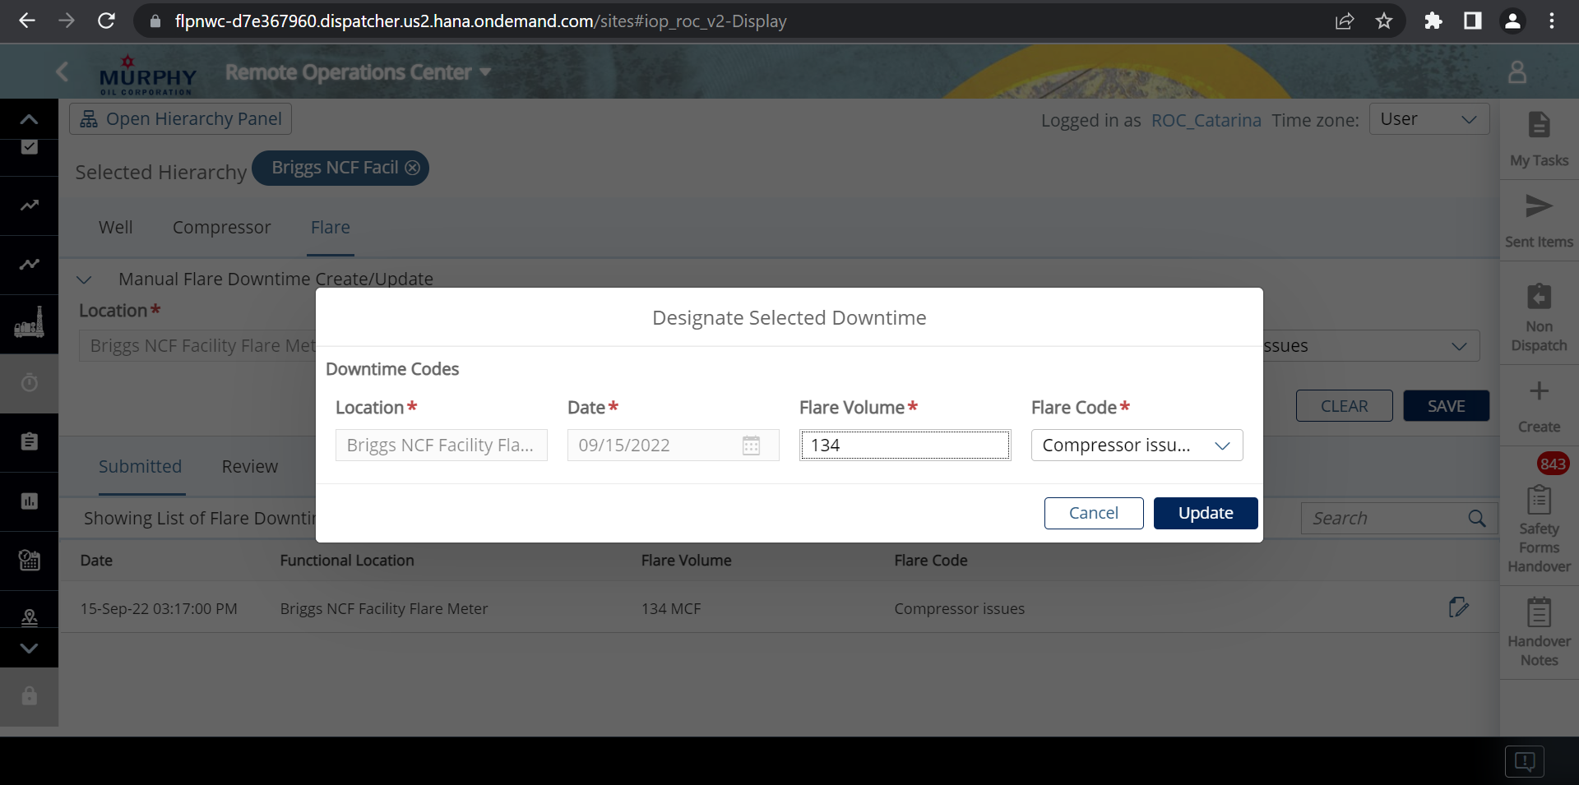

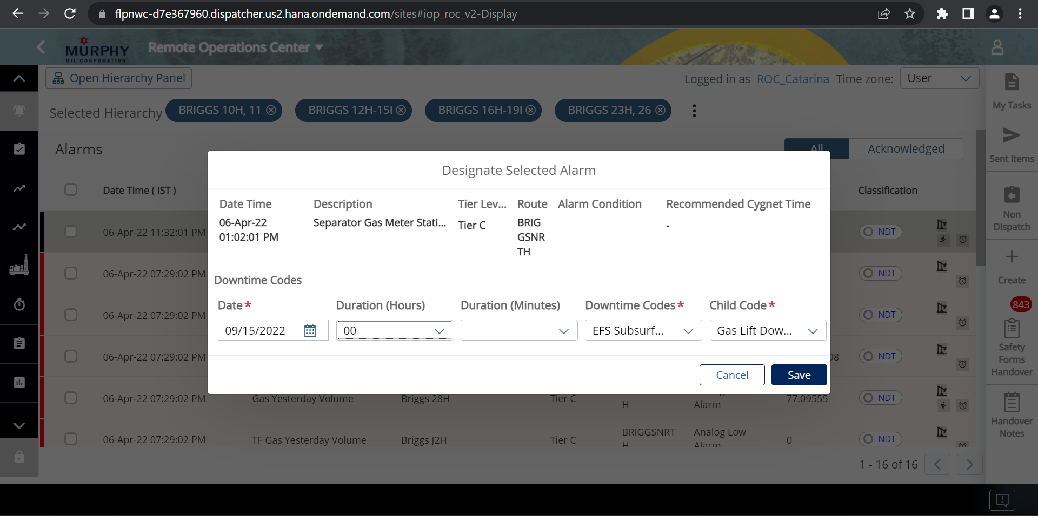

no procount/prodview comments on dispatch task closure:

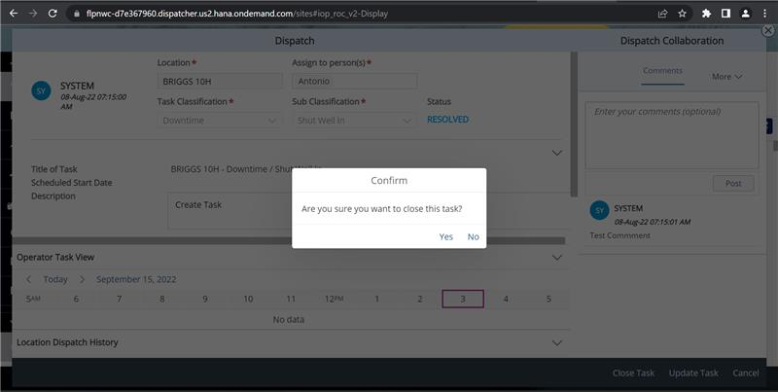

No procount/prodview comments on inquiry closure:

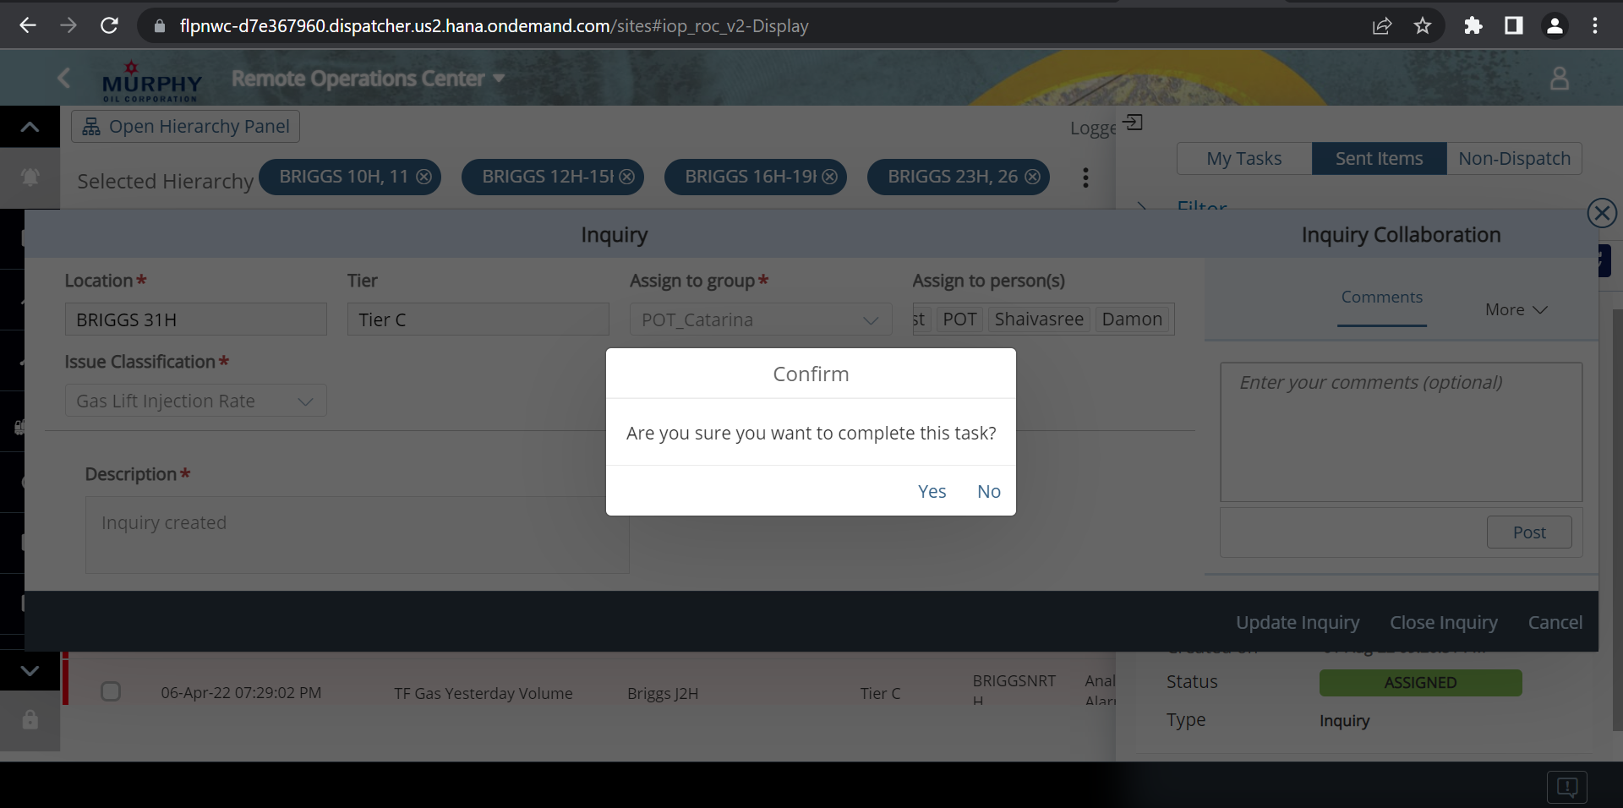

PM App- Workorder

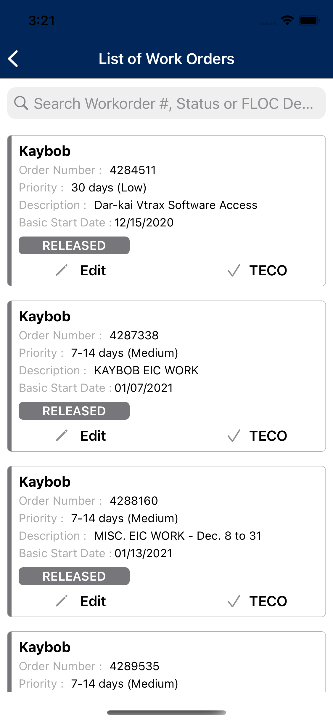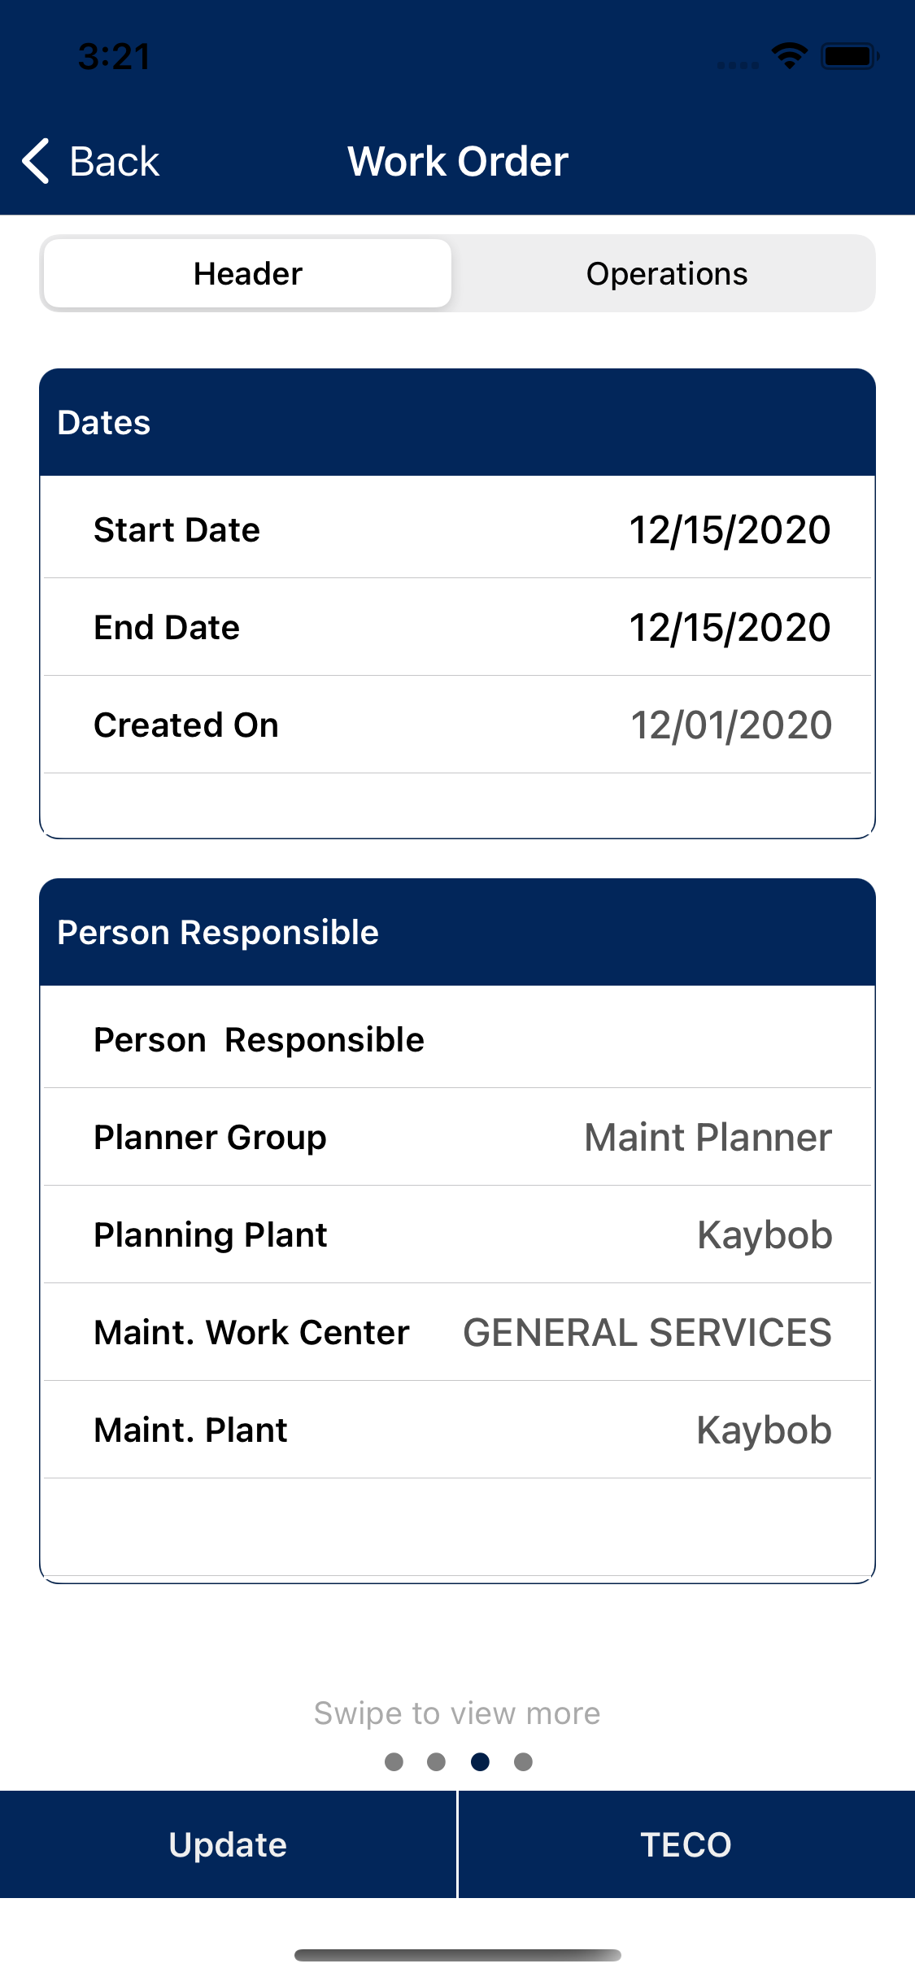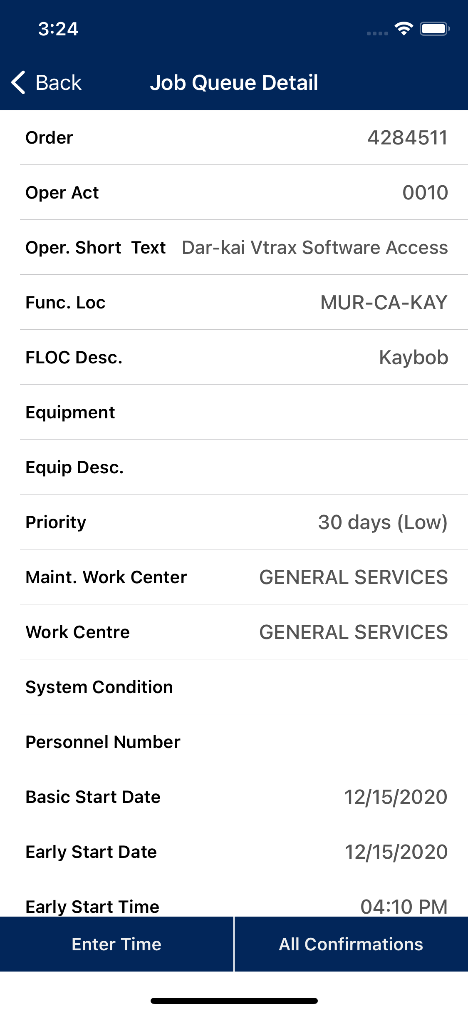

Handover Notes:

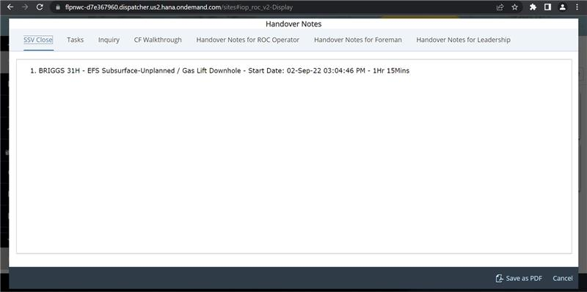

push Notification:

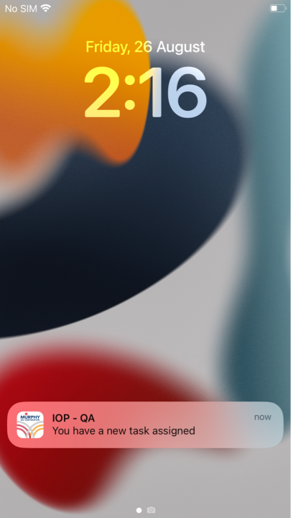

No option for an engineer to edit a frac pack or mark complete:

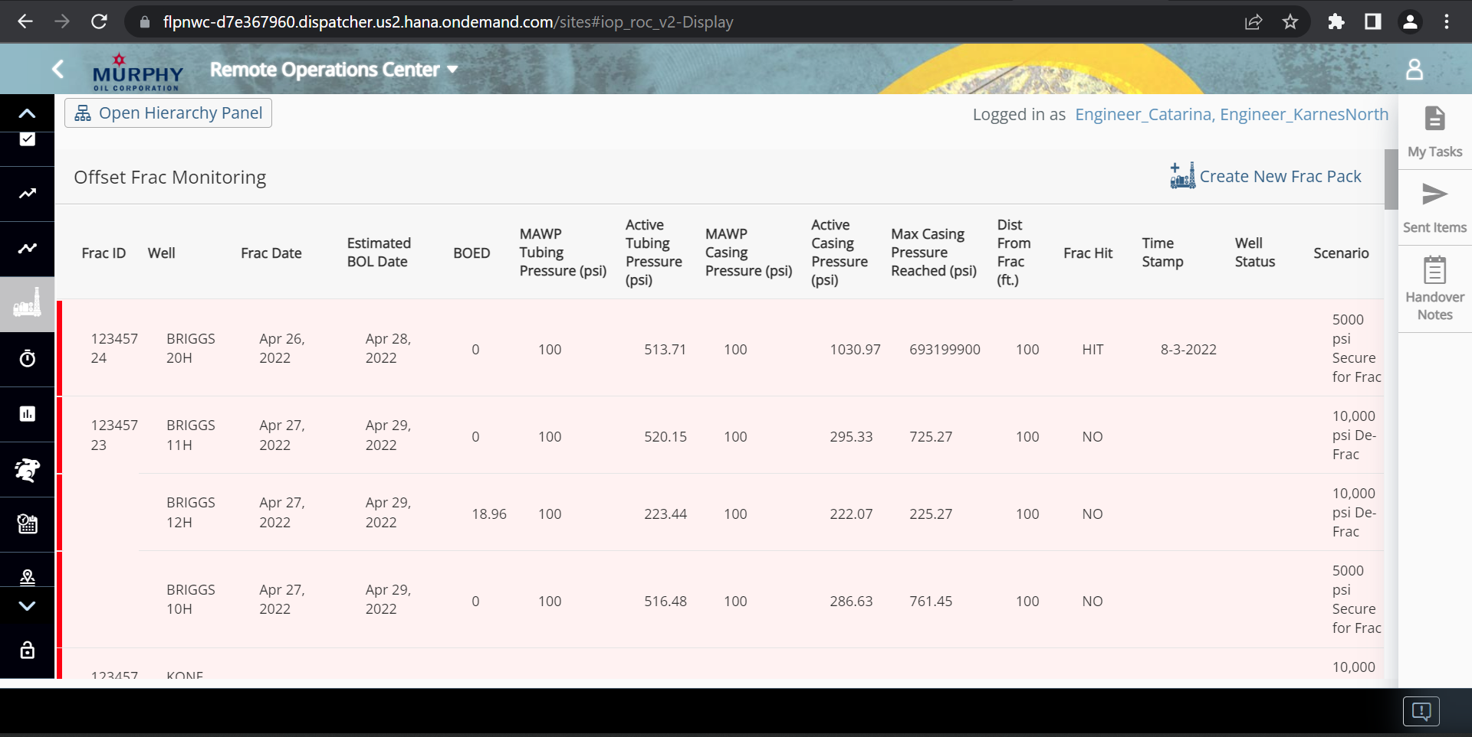

## Glossary of Terms: - Optional

| **Term** | **Definition** |
| --- | --- |
| BRD | Business Requirement Document |
| ROC | Remote Operations Controller (usually stationed in Houston office, interacts via IOP Web app) |
| PRO or Field Ops. | Production Recovery Operator (usually stationed near production facilities, interacts via IOP mobile app) |
| IOP | Integrated Operations Platform |
| SAP PM | SAP Plant Maintenance (PM) is a component of the SAP ERP Central Component (ECC) that helps businesses support and maintain equipment and systems |
| Spotfire | Data visualization and Analytics software by TIBCO, used by Murphy to build reports. |